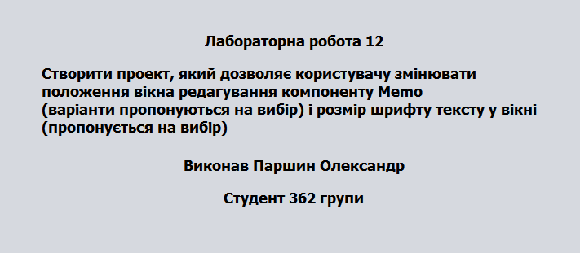

/\*

\*/

package Lab12;

import java.awt.Font;

import java.awt.Point;

import javax.swing.JOptionPane;

;

/\*\*

\*

\* @author parsh

\*/

public class lab12 extends javax.swing.JFrame {

/\*\*

\* Creates new form lab12

\*/

public lab12() {

initComponents();

jTextArea2.setVisible(false);

jTextArea3.setVisible(false);

}

private void FONT(float newSize)

{

jTextArea1.setVisible(false);

jTextArea2.setVisible(false);

jTextArea3.setVisible(false);

jTextArea1.setFont(new Font(jTextArea1.getFont().getFontName(),Font.BOLD, (int)newSize));

jTextArea2.setFont(new Font(jTextArea2.getFont().getFontName(),Font.BOLD, (int)newSize));

jTextArea3.setFont(new Font(jTextArea3.getFont().getFontName(),Font.BOLD, (int)newSize));

}

private void jButton1ActionPerformed(java.awt.event.ActionEvent evt) {

// TODO add your handling code here:

float type1 = Float.parseFloat((String)jComboBox4.getSelectedItem());

FONT(type1);

String type = (String)jComboBox2.getSelectedItem();

if("Слева в верху".equals(type))

{

jTextArea1.setVisible(true);

}

if("Слева в низу".equals(type))

{

jTextArea2.setVisible(true);

}

if("Справа в низу".equals(type))

{

jTextArea3.setVisible(true);

}

}

private void jComboBox2ActionPerformed(java.awt.event.ActionEvent evt) {

// TODO add your handling code here:

}

/\*\*

\* @param args the command line arguments

\*/

public static void main(String args[]) {

/\* Create and display the form \*/

java.awt.EventQueue.invokeLater(new Runnable() {

public void run() {}});

}

public static void sVisible(boolean a)

{

new lab12().setVisible(true);

}

// Variables declaration - do not modify

private javax.swing.JButton jButton1;

private javax.swing.JComboBox jComboBox2;

private javax.swing.JComboBox jComboBox4;

private javax.swing.JTextArea jTextArea1;

private javax.swing.JTextArea jTextArea2;

private javax.swing.JTextArea jTextArea3;

// End of variables declaration

}

